Section 1: Case Summary

Scenario Title: | Pediatric Multisystem Inflammatory Syndrome (COVID-19)
Keywords: | Pediatric, infectious disease, provider safety, cardiogenic shock
Brief Description of Case: | Team must safely and effectively manage a critically ill pediatric patient with cardiogenic shock from multi-system inflammatory syndrome, linked to COVID-19.

Goals and Objectives
Educational Goal: | Recognition and management of cardiogenic shock, secondary to multisystem inflammatory syndrome, likely COVID19.
Systems Objectives: | Identify systems-level opportunities to improve care of a child presenting with critical illness and a high-risk IPAC precautions.
Objectives:  (Medical and CRM) | - Recognition of potential COVID-19 MIS signs and symptoms  - Effective team communication from triage to PICU of a critically ill patient  - Appropriate donning and doffing of PPE to mitigate risk of COVID-19 exposure  - Conducting effective high acuity clinical care in space and personnel limited negative pressure room effectively  - Appropriately isolation practices of high-risk patient contacts (parents)  - Safe use of high risk vasoactive medication  - Effective consultation with PICU, Cardiology and IPAC colleagues
Infection Prevention and Control Objectives  (See Appendix C for details) | The guidelines for the novel coronavirus and data surrounding Pediatric Multi-System Inflammatory Syndrome are changing frequently as we receive new information about the virus and its sequelae. Infection prevention and control (IPAC) considerations also vary between institutions. Please review your institution’s most up-to-date guidelines before running the simulation.
EPAs Assessed: | Case not designed to address EPAs

Learners, Setting and Personnel
Target Learners: | ☐ Junior Learners |  | ☐ Senior Learners |  |  | ☒ Staff
 | ☒ Physicians | ☒ Nurses |  | ☒ RT | ☒ Inter-professional
 | ☒ Other Learners: Unit clerks, IPAC, ID, PICU teams
Location: | ☐ Sim Lab |  | ☒ In Situ |  |  | ☐ Other:
Recommended Number of Facilitators: | Instructors: 1
 | Confederates: 1 (parent)
 | Sim Techs: 1

Scenario Development
Date of Development: | May 20, 2020
Scenario Developer(s): | Drs. Meagan Doyle and James Leung
Affiliations/Institutions(s): | McMaster University
Contact E-mail: | doylem13@mcmaster.ca OR leungj16@mcmaster.ca
Adapted from:
Revised By: | Dr Alim Pardhan, Claudiu Serbanescu
Version Number: | 1

Section 2A: Initial Patient Information

- Patient Chart
Patient Name: Elliott |  |  |  | Age: 7 | Gender: M | Weight: 20kg
Presenting complaint: Fever, lethargy
Temp: 39.2 | HR: 160 | BP: 92/56 |  | RR: 38 | O₂Sat: 92% | FiO₂: RA
Cap glucose: 6.1 |  |  |  | GCS: 14
Triage note:
6 days of illness that started with fever, fatigue. Rash started 3d ago and diarrhea started 24hrs ago. Only one episode of urination in past 24hrs, but can’t be sure because of the diarrhea. Parents are health care providers.

Allergies: None
Past Medical History:  Healthy. No Admissions. No Surgeries.  Immunizations: Up to date |  |  | Current Medications:  Ibuprofen, Acetaminophen

Section 2B: Extra Patient Information

A. Further History
Per parent
The child developed fever 6 days ago. For the first few days of fever, the patient was tired but continued to play with siblings. Ibuprofen and acetaminophen were given to reduce fever with effect. The child has had decreased intake of solids, but has been hydrating with oral liquids until about 24hrs ago. Parents have been diligently providing fluids, including pedialyte. Yesterday the patient required more prompting to take fluids. This morning, he has been increasingly difficult to rouse, and continues to be febrile, prompting parents to bring him to the ED for care. He usually wakes up around same time as siblings, between 6 and 7am, but parents had to wake him this morning at 7:45. He was difficult to rouse and quickly went back to sleep, so was brought immediately to emergency.

The patient also developed a rash 2-3 days ago. Initially the rash was limited to a few pink to red spots on torso and slight redness to hands, noticed in hindsight. Now head to toe patchy raised pink/red rash.
Lips have also been a bit more red. No conjunctivitis history.

Diarrhea – 7 episodes in 24hrs. Large volume, watery. Non-bloody, no melena.
Urine output, only one known in past 24hrs – just after family lunch time. Has had multiple watery diarrhea stools since and a bath.

Pt has 2 younger siblings aged 2 and 4, healthy
They have a live-out Nanny who has been at the house daily when both parents are working. She has been attentive to physical distancing and handwashing. No one at home has been sick.

Family History: No Auto-immune conditions. No history of Sudden Cardiac death.

Social History: Mom is a hospital-based physician with known COVID patient contact. Dad works as a nurse practitioner at an inner city health centre.

B. Physical Exam
List any pertinent positive and negative findings
Cardio: Cool hands and feet with 3-4 sec CR, 2s CR central. Tachycardia. Low BP. Gallop Rhythm. | Neuro: tired. Requires prompting to follow commands, open eyes spontaneously, slow to answer questions
Resp: Mild WOB, no crackles or wheeze. Tachypneic | Head & Neck: red lips and tongue
Abdo: Mild hepatosplenic enlargement – liver at costal margin | MSK/skin: CRT 3-4s. Red peeling rash to fingers and toes. Generalized maculopapular rash
Other: No edema

Section 3: Technical Requirements/Room Vision

A. Patient
☒ Mannequin: Child
☒ Standardized Parent
☐ Task Trainer
☐ Hybrid
B. Special Equipment Required
*Epi spritzer: push dose epinephrine, see attached protocol
Resus room
Defibrillator
C. Required Medications
0.9% Saline
Ceftriaxone
Hydrocortisone
Epinephrine
Dobutamine or Milrinone
D. Moulage
Optional: Manniquen with red fingers/toes, generalized erythematous rash, photo of facial rash of Kawasaki disease
E. Monitors at Case Onset
☐ Patient on monitor with vitals displayed
☒ Patient not yet on monitor
F. Patient Reactions and Exam
Include any relevant physical exam findings that require mannequin programming or cues from patient
(e.g. – abnormal breath sounds, moaning when RUQ palpated, etc.) May be helpful to frame in ABCDE format.
A – Patent airway, decreased LOC
B – Mild increased WOB, GAEB, no crackles no wheeze. Tachypneic.
C - Tachycardic and febrile, CR 3-4s, Gallop Rhythm
D – Lethargic, eyes open to speech, speaks and moves intentionally with prompting

Section 4: Sim Actors and Standardized Patients

Sim Actors and Standardized Patient Roles and Scripts
Role | Description of role, expected behavior, and key moments to intervene/prompt learners. Include any script required (including conveying patient information if patient is unable)
Parents | Either parent – medically knowledgable but not obstructive. Trusts the team. Feels guilty about waiting so long “I wondered if we should have brought him in last night.” and even more guilty about possibly bringing an infection home from work. Will provide information in Section 2B when prompted.

Section 5: Scenario Flow

Scenario States, Modifiers and Triggers
Patient State/Vitals | Patient Status | Learner Actions, Modifiers & Triggers to Move to Next State |  | Facilitator Notes
1. ED entry + Triage  Rhythm: Sinus tach  HR: 160  BP: 93/52  RR: 38  O₂SAT: 91%RA  AVPU: Awake  T: 39.2ºC | Child mannequin into ED by parent in wheelchair  Parent calm, cooperative but worried. | Expected Learner Actions  Apply mask to patient  Apply mask to parent  Obtain triage vital signs  Move to resuscitation/neg pressure room  Triage RN to contact MD and bedside team with details  HCPs don appropriate PPE | Modifiers  Changes to patient condition based on learner action  Triggers  For progression to next state  - Move patient to neg pressure room, handover to bedside team | Team should use N95 impermeable and face shields once airborne generating medical procedure (AGMP) being considered.
2. Initial Assessment  Rhythm: Sinus tach  HR: 160  BP: 92/50  RR: 36  O₂SAT: 91% RA  T: 39.2ºC  AVPU: Verbal  Gluc: 6.3 | Mild increased WOB  Peripheral pulses weak  Requires prompting to follow commands, open eyes spontaneously, slow to answer questions | HCPs in appropriate PPE before entering room  Conduct resuscitation in “protected” conditions  Monitors  IV access (IO if needed)  Apply O₂ by NRB mask  Portable Xray, Labs, ECG  Point of care ultrasound  Call RT  Primary and secondary survey  IV Bolus – 10-20ml/kg  Antibiotics | Modifiers  O₂SAT 94% on NRB  Triggers  - Fluid bolus administration done, move to next stage | Technically, “appropriate” PPE: HCP can be in droplet/contact precautions up until AGMP performed.  If high skilled team, could require IO instead of IV  POCUS – no pericardical effusion, hypokinetic LV, IVC partial collapse with inspiration
3. Cardiogenic Shock  Rhythm: Sinus Tach  HR: 180  BP: 84/48  RR: 35  O₂SAT: 92% on NRB  AVPU: Pain | Patient becoming more lethargic and circulation worsens. No improvement with fluid boluses. | Judicious fluids – 10ml/kg bolus  Order vasopressor infusion  *Epi spritzer as bridge to infusion  Consult Cardiology, PICU (may be via telemedicine) | Modifiers  -If aggressive fluids (20ml/kg boluses) – increase HR, decrease BP  Triggers  - Move to next stage if ordered Epi infusion | *Epi spritzer: push dose epinephrine, see attached protocol  Re pressors, consider:  - Epinephrine  - Dobutamine  - Milrinone
4. Progressive Cardiogenic Shock  HR 180  BP 80/40  RR 30  O2 90% on NRB | Ongoing lethargy and poor peripheral perfusion | Expected Learner Actions  Place Defib pads on pt if not already done  Epinephrine Infusion started  0.05 – 0.1mcg/kg/min  (Consider epinephrine spritzer if infusion not ready)  Consider for fluid and vasopressor resistant cardiogenic shock: Hydrocortisone  Call PICU  May discuss intubation indications, risks, benefits, safety considerations – should discuss HCP PPE | Modifiers  LOC changes with BP  BP slowly improves to 85/50 with Epi spritzer  Or after 3 min from starting Epi infusion dosing and titrating up to 0.5mcg/kg/min will produce desired BP  max 1mcg/kg/min  Triggers  Move to next stage when epi at 0.5mcg/kg/min | HCP team should not proceed to intubation yet as circulatory state is unstable, and patient could arrest with RSI/positive pressure ventilation  See attached paper for MUMC PED/PICU Epi Spritzer protocol
5. Stabilization  HR 160  BP 85/50 90/65  RR 28  O2 92% NRB | A – no change  B – no change  C – CR 3s P, 2sC, Central pulses strong, peripheral pulses improved. +gallop unchanged  D – LOC improves with increased BP – still tired but will rouse briefly to voice, protecting airway. | Consider intubation for decreased level of consciousness and anticipated clinical course  HCPs must be in airborne PPE if intubate  Discussion re:?COVID. Swab done  Identify potential exposed persons, nature of exposure  Liaise with IPAC (or local equivalent) | Modifiers  Triggers  - All actions complete *END CASE | END CASE ANYTIME.

Appendix A: Laboratory Results

VBG
pH 7.25
pCO2 33
pO2 30
HCO3 13
Lactate 3.0

CBC
WBC 23.6
Neut 20.7
Lymphs 1.4
Hb 114
Plt 161

Lytes
Creatinine 122
Urea 6.1
Na 131
K 4.6
CO2 15
Cl 102

Cardiac
INR 1.1
D-Dimer 3798
Troponin 1004

Other
Ferritin 28,000
CRP 172
AST 57
LDH 976

Appendix B: ECGs, X-rays, Ultrasounds and Pictures

Paste in any auxiliary files required for running the session. Don’t forget to include their source so you can find them later!

CXR: Case courtesy of Dr Jeremy Jones, Radiopaedia.org, rID: 41667
https://radiopaedia.org/cases/normal-chest-x-ray-6-year-old
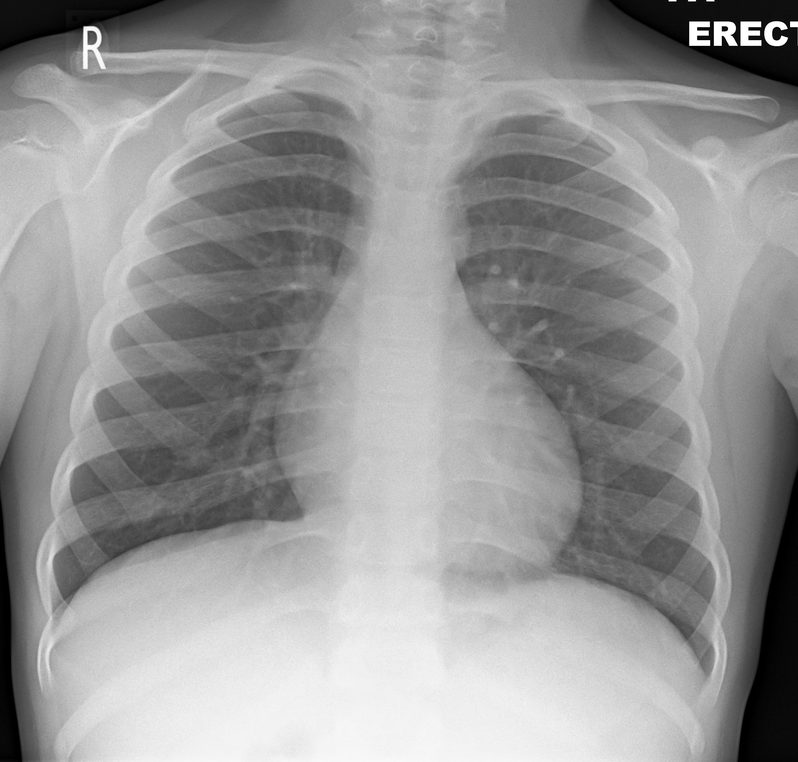

Facial features of Kawasaki Disease: Accessed from Wikipedia at:
https://commons.wikimedia.org/wiki/File:Kawasaki_symptoms_B.jpg#/media/File:Kawasaki_symptoms_B.jpg

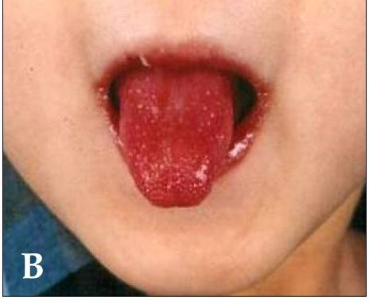

ECG: https://en.ecgpedia.org/images/4/45/E000535.jpg
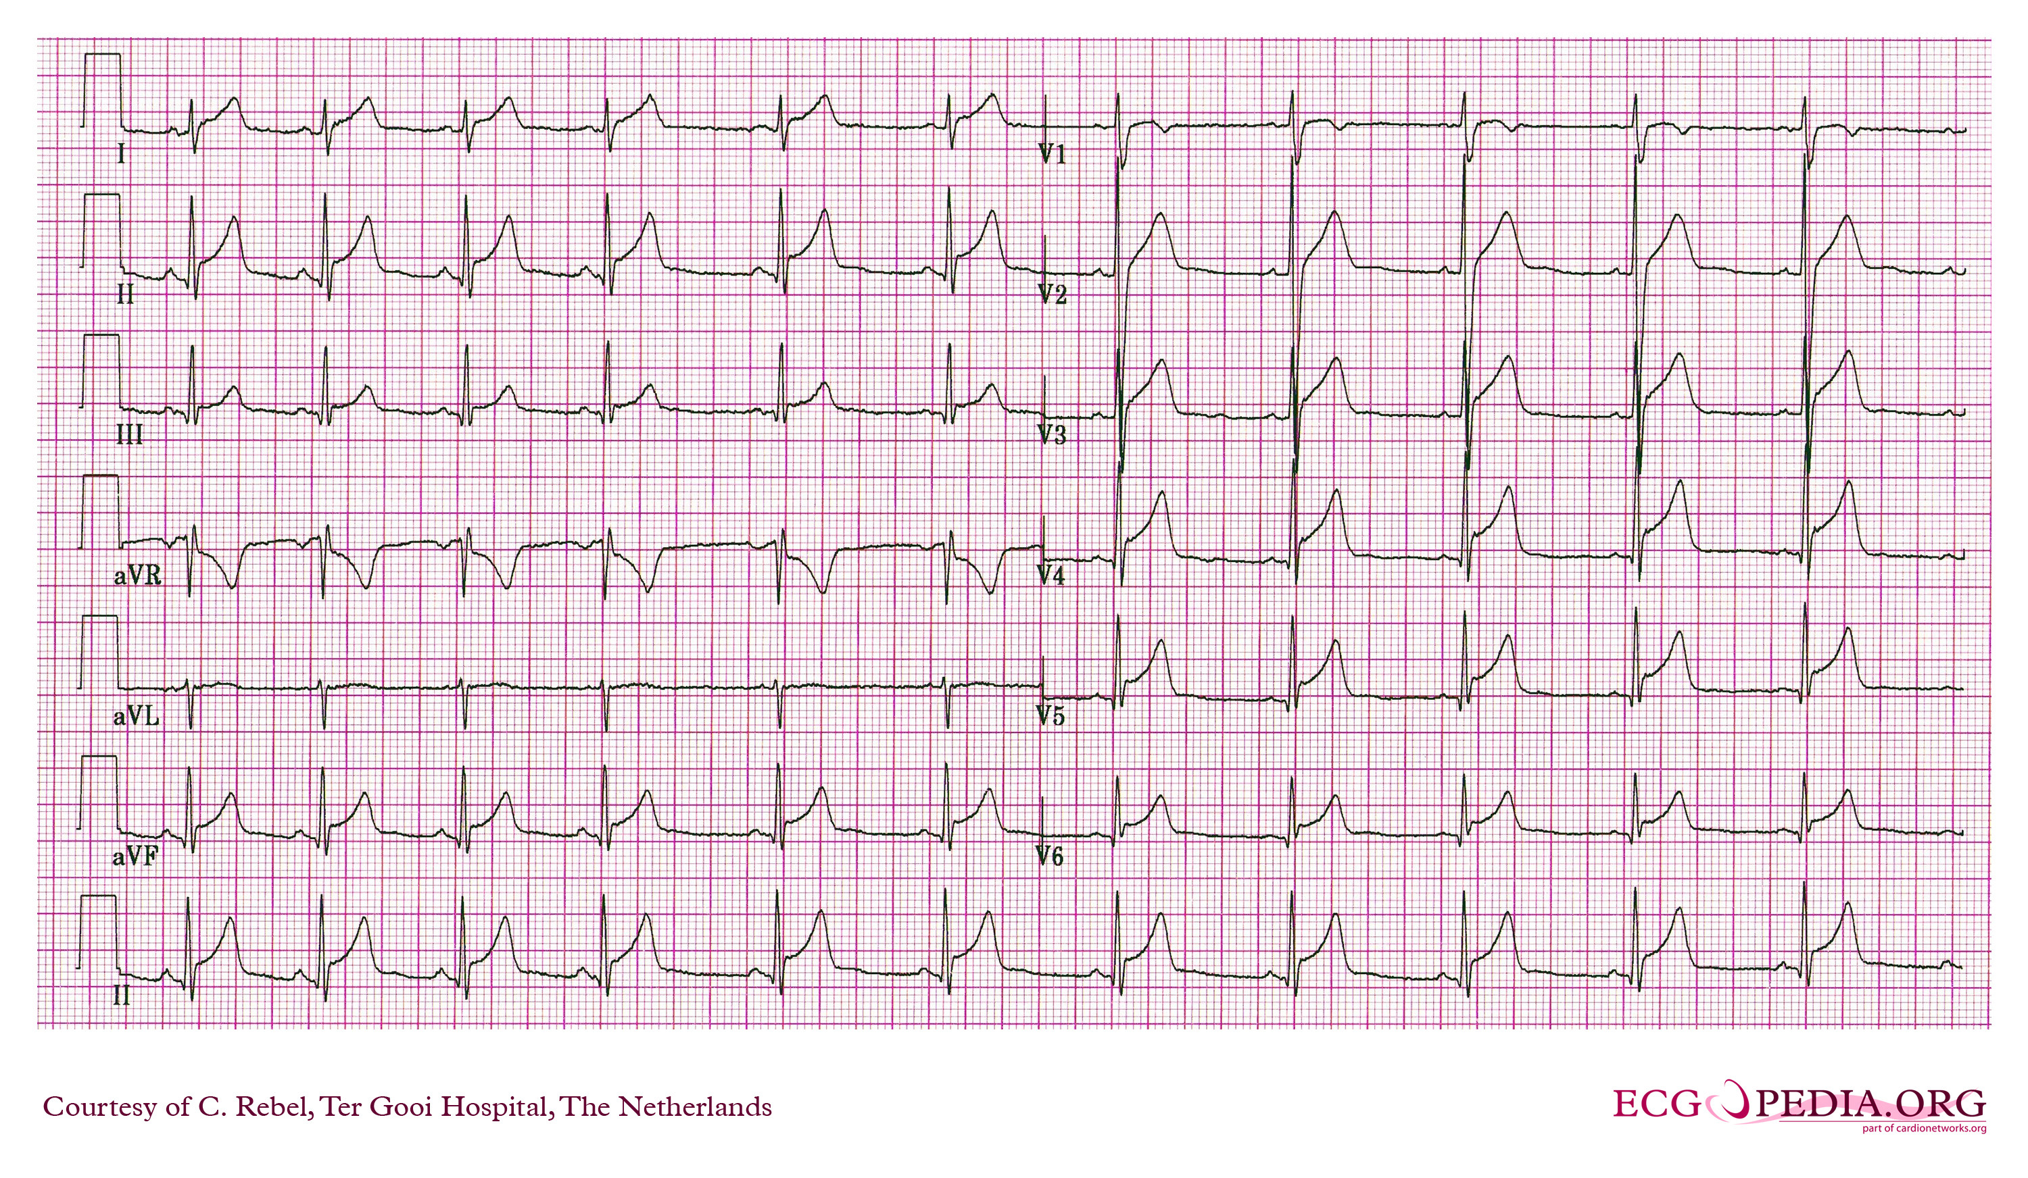

POCUS: https://www.acep.org/sonoguide/cardiac.html - use video clip 6

Appendix C: Facilitator Cheat Sheet & Debriefing Tips

In Situ Simulation for Continuing Professional Development
This case is part of a series of simulation exercises run during the Spring of 2020 at McMaster Children’s Hospital. Our goal is to highlight key clinical features of COVID 19 while learning how to navigate increased infection control measures with a particular focus on process improvement and patient and provider safety threats.

As evidence is mounting regarding a spike in a Multisystem Inflammatory Syndrome in Pediatric patients, thought to be related to COVID 19 this case highlights a severe outcome of this syndrome.

Pediatric Cardiogenic Shock Considerations
- What are the findings of Kawasaki disease/atypical Kawasaki disease?
- How is pediatric cardiogenic shock managed? Acutely or in the PICU? Additional considerations (assessment for coronary thrombous and potential treatment?)

Infection Prevention and Control Considerations

The guidelines for the novel coronavirus are changing frequently as we receive new information about the virus. Infection prevention control (IPAC) considerations also vary between institutions. Please review the most up-to-date guidelines and discuss with your IPAC team before running the simulation.

Below are some suggested considerations for review.

- Should the team be kept smaller to mitigate risk to healthcare team/exposure?
- What personal protective equipment (PPE) must providers wear? RT/Intubating MD?
- What mask/PPE should patients be wearing if high risk and being transferred (i.e. from triage to room, to imaging)
- How does this “protected” resuscitation differ from resuscitations conducted in previous times?
- Who activates IPAC and when?
- What swabs/investigations need to be sent?
- What interventions should be avoided (BiPaP, nebs…)?
- What are next steps for staff members who may have been inadvertently exposed?
- What are the appropriate decontamination measures for equipment (ultrasound)? Should these pieces of equipment not be brought into the room?
- How will we bring equipment (medical supplies, x-ray machine) through the ante room?
- How will the team in the isolation room communicate with the team outside the room?

References

- https://www.rcpch.ac.uk/sites/default/files/2020-05/COVID-19-Paediatric-multisystem-%20inflammatory%20syndrome-20200501.pdf
- https://www.thelancet.com/action/showPdf?pii=S0140-6736%2820%2931103-X
- https://dontforgetthebubbles.com/pims-ts/

